Valleyview Community Church

June 14, 2020

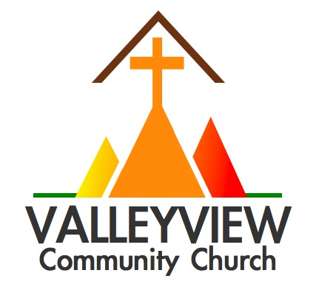

For all events, ministries, & info visit

www.valleyviewcommunitychurch.ca

**Sermon Notes**

**This Week at a Glance**

**Tuesday & Thursday:** Mid-Day Prayer (via Zoom video) (12-12:30pm)

**Table Talk Tuesday:** Zoom video hangout (6:30-7:30pm)

**Saturday:** Food Deliveries (9:00am load up and deliver from Froogles)

**Next Sunday:** The Grand Story: We Want a King!

0-3  0

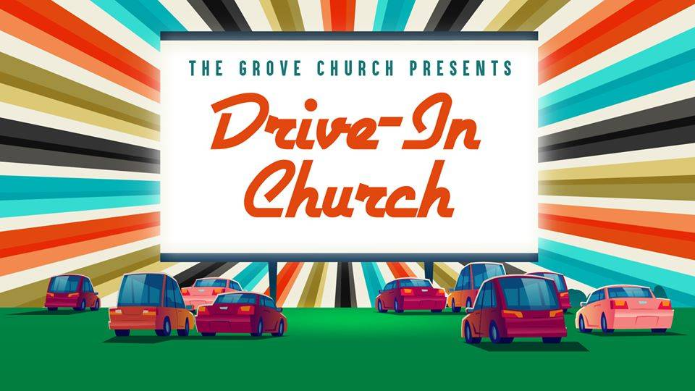

Beginning Sunday, June 14 we will be having outdoor parking lot services from 6-7pm. Everyone is welcome to attend in vehicles and to invite friends/family to join us for these drive-in style parking lot services over the summer months.

The Israelites did evil in the eyes of the Lord; they forgot the Lord their God and served the Baals and the Asherahs.

**Judges 3:7**

**Table Talk Tuesdays**

**(6:30-7:30pm)**

Every Tuesday from 6:30-7:30pmpm we will be reviving our Table Talk Tuesdays via Zoom video chat. Join us for an opportunity to connect and hangout together.

Every Wednesday we will release a new episode on our new Tapestry podcast sharing stories from members of our church family about their journey with Jesus.

Track along each week at www.valleyviewcommunitychurch.ca/tapestry-podcast

TAPESTRY

**The Grand Story: Judges**

Breaking Bad

**Parking Lot Worship Services**

**Sundays (6:00-7:00pm)**

**Tapestry Podcast**

**New Episode Every Wednesday**

**The Grand**

**Story**



**Rev. Jason Tripp**

2891 Martin Rd. Blezard Valley, ON P0M 1E0

(705) 897-6200 / valleyviewsudbury@gmail.com

**Part of the Free Methodist Church in Canada**

**www.fmcic.ca**

**Imagine** knowing **love** that **heals** hearts, **mends** families & **cares** for community.

This love **flows** through lives committed to **Jesus.**

**Questions for Reflection & Discussion**

1. How does today’s message encourage and/or challenge you in your faith?
2. How does the graphic violence of Judges make it difficult to read? How does the book soberingly serve as a mirror reflecting the destructiveness of sin, violence and idolatry?
3. How is the cycle of Israel in Judges (see image to the right) a reality in our lives and society today? How have you witnessed both the destructiveness of sin and the forgiving grace of God?
4. What are some ways in which you/we can stop the cycle in our lives and society? How can we be on guard against the temptation to misuse and abuse our God given freedom and authority? Spend time sitting with Jesus to reflect further this week.

It is for freedom that Christ has set us free. Stand firm, then, and do not let yourselves be burdened again by a yoke of slavery. **– Galatians 5:1**

Today, we continue our journey through the Grand Story of Scripture as we look at themes in the book of Judges as Pastor Jason shares a message entitled Breaking Bad.

Judges picks up where Joshua leaves off as the Israelites continue to do battle against the other residents in the land they are settling in having been rescued from Egypt and wandering through the wilderness.

Judges is a book permeated with graphic violence and evil of many grotesque forms. In many ways the downward spiral of Israel in Judges parallels the popular TV show Breaking Bad which follows the tragic story of Walter White, a high school chemistry teacher who, when discovering he has terminal cancer, begins cooking drugs as a means of providing money for his family before he dies. While his intentions to provide for his family are noble, his choices and the allure of power lead Walter on a downward and destructive path.

This is similar to the story of Israel in Judges. The book repeatedly says the Israelites “did evil in the sight of the Lord” leading to escalating violence, bloodshed and a body count of an estimated 285,633. Clearly to take Judges seriously is not to read it looking to emulate the morality of the key figures in this book. Samson and the other judges in the book act more like gangsters and mob bosses than those we would want to emulate. And yet, in the midst of repeated evil and idolatry, God continues to strive with Israel, even has he lets the catastrophic cycle of sin and judgment run its course. As hard to read as Judges can be with all the grotesque violence and murder it is a powerful reminder of the way in which our freedom in Christ and power and authority granted to us can be used for selfish and sinful purposes with tragic consequences.

**The Grand Story: Judges**

Breaking Bad

**Questions for Reflection/Discussion**

1. What did you learn from this morning’s message? What encouraged you? What challenged you?
2. How does the act of forgiveness shift the power between people?
3. What does it mean to heap burning coals upon someone’s head? How do you know when it’s time to just heap hot coals on someone’s head?
4. What practical steps can you take to practice the upside down aikido forgiveness with someone?

This morning we wind down our Love over Fear series focusing on the theme of forgiveness.

In the world of martial arts Aikido is the most difficult to teach and learn because it is so counterintuitive. The power of aikido is from a strategic noncombative posture involving the ability to absorb and redirect combative force. Aikido, like forgiveness is difficult to learn and practice, because they involve relaxing when being threated and maintaining control and focus.

Much like the volatile and violent world in which Jesus lived in, we live in a world where it is easier and often more impulsive to ‘fight fire with fire’ and to respond in kind when we are threatened and attacked by others, and yet Jesus teaches us the upside down way of forgiveness. In his Sermon on the Mount, Jesus teaches us the way of forgiveness and radical self-giving love which, although difficult and counterintuitive, is the way in which the world is ultimately healed and reconciled. The cross is the definitive revelation of the power and love of God and it is through forgiveness and love ultimately conquers over fear

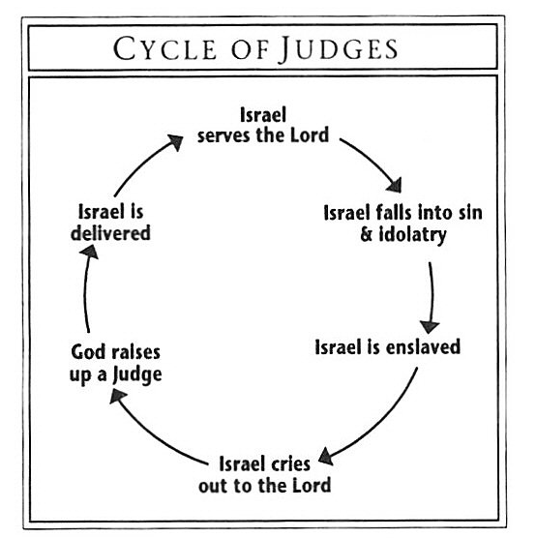





**Generosity - eGiving now Available**

For those interested, eGiving is now available at VCC. All eGiving donations can be emailed to [**valleyviewfinancial@gmail.com**](mailto:valleyviewfinancial@gmail.com) with the following security question and answer:

**What church do I attend? valleyview**

:

Thanks to all of today’s volunteers who serve in areas of passion and giftedness.





j