

Valleyview Community Church

October 4, 2020

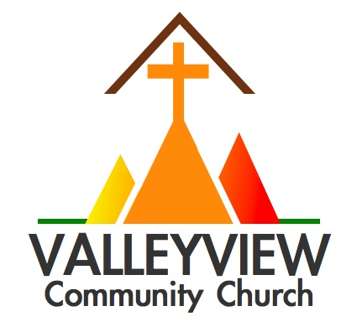

For all events, ministries, & info visit

www.valleyviewcommunitychurch.ca

**Sermon Notes**

**This Week at a Glance**

**Life Together Tuesdays (via Zoom)**

Mid-Day Prayer (12-12:30pm)

Table Talk Tuesday (6:30-7:30pm)

**Next Sunday:** The Grand Story – Lamentations: The Road to Thanksgiving

0-3  0

This is what the Lord of Heaven’s Armies, the God of Israel, says to all the captives he has exiled to Babylon from Jerusalem: “Build homes, and plan to stay. Plant gardens, and eat the food they produce. Marry and have children. Then find spouses for them so that you may have many grandchildren. Multiply! Do not dwindle away! And work for the peace and prosperity of the city where I sent you into exile. Pray to the Lord for it, for its welfare will determine your welfare.”

**Jeremiah 29:4-7**

**Jeremiah: Life in Exile**

The Grand Story

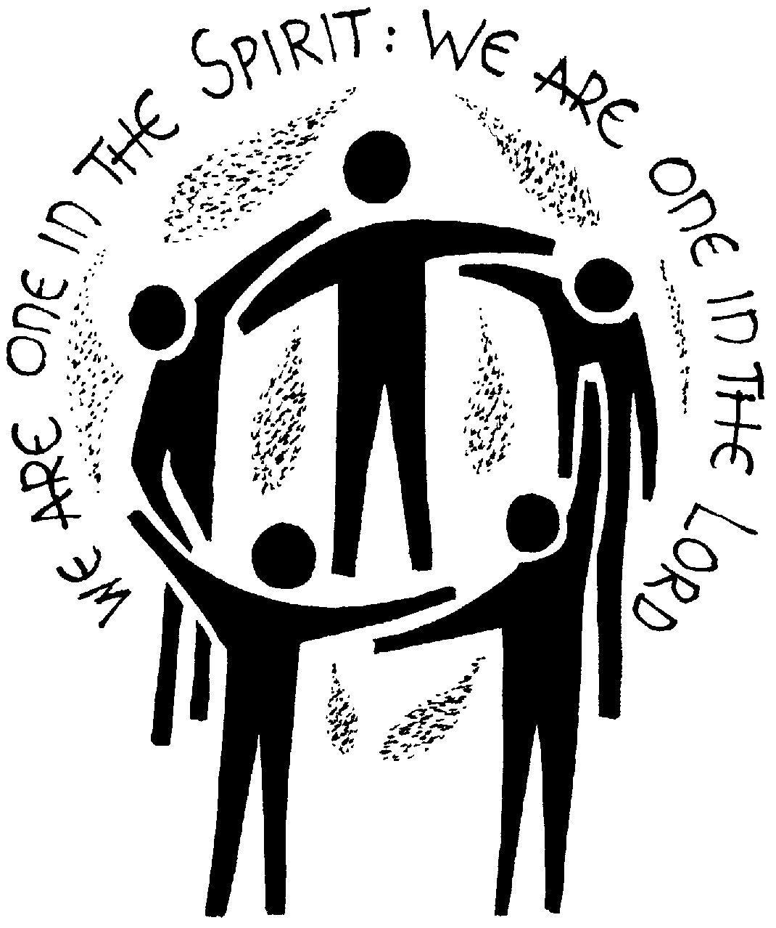



Since the outbreak of the COVID-19 pandemic in March, Valleyview Community Church has delivered over 3000 food deliveries to the vulnerable and impoverished in our community. We will continue to fulfill the shop and deliver orders for Metro throughout the fall and winter. If you would like to volunteer please contact Pastor Jason.

**Grocery Deliveries for Seniors (Reaching Out)**

**Life Together Tuesdays (Reaching In)**

Beginning Tuesday, September 22 we will be launching our “Life Together Tuesdays” offering two virtual opportunities to gather for prayer, and meaningful conversation.

**Mid-Day Prayer (12-12:30pm)**

**Table Talk Tuesdays (6:30-7:30pm)**

After 6 months of virtual and parking lot gatherings we are re-opening our sanctuary for Sunday worship. Join us from 10:30-11:30am for Sunday worship in a safe environment. For those not yet ready to join in person we will be recording services and making them available for home viewing.

**Sunday Mornings: In-Person & At Home (Reaching Up)**

**Rev. Jason Tripp**

2891 Martin Rd. Blezard Valley, ON P0M 1E0

(705) 897-6200 / valleyviewsudbury@gmail.com

**Part of the Free Methodist Church in Canada**

**www.fmcic.ca**

**(Re)Imagine** knowing **love** that **heals** hearts, **mends** families & **cares** for community.

This love **flows** through lives committed to **Jesus.**

In despair, you will be led into exile with your hands on your heads, for the Lord has rejected the nations you trust. They will not help you at all.

* **Jeremiah 2:37**

Continuing our epic journey through the Grand Story of Scripture, today we encounter another one of the most well known of the Old Testament prophets, Jeremiah.

Jeremiah lived and prophesied before and during the period of exile, when Jerusalem and the Southern Kingdom of Judah were conquered by the neighbouring Babylon, displacing, and leaving the people of Israel discouraged and disoriented.

Exile is a major theme in the Old Testament. The destruction of the city of Jerusalem and the temple was in a sense the end of the world as they knew it and they were forced to live in exile as strangers and foreigners under the Babylonian regime.

While we live in a different place and time, the motif of exile is very real and relevant to the church in our day and context. As the religious landscape has shifted dramatically in Canada in recent years it can feel as though the church in contemporary Canada is living in a sort of exile.

While it can be tempting to either uncritically accommodate the cultural winds of change, or to resort to a bunker mentality, criticizing our culture from a safe distance, the message from God through the prophet Jeremiah is to live respectfully as exiles, working for the common good, while maintaining ultimate allegiance and fidelity to Christ. While the prophet Jeremiah (and Daniel) lived in a time far removed from our own, the similarities are striking and deserve our thoughtful attention, informing us on how to live faithfully to God as resident aliens in 21st century Canada.

**Questions for Reflection & Discussion**

1. How does today’s message encourage and/or challenge you in your faith?
2. What is the significance of the motif of exile in our journey through Scripture? How does this theme compare and contrast with our contemporary world?
3. How can living in the world as a follower of Jesus be called living as a “resident alien”? How does living and working for the common good, while maintaining ultimate allegiance to Christ present both opportunities and challenges?
4. How is Jeremiah’s letter to the Israelites in Babylonian exile (Jer. 29:1-23) applicable to us as we strive to live as faithful followers of Jesus in a secular age? Read this letter throughout the week, noting anything God puts on your heart.

**Jeremiah: Life in Exile**

The Grand Story

**Questions for Reflection/Discussion**

1. What did you learn from this morning’s message? What encouraged you? What challenged you?
2. How does the act of forgiveness shift the power between people?
3. What does it mean to heap burning coals upon someone’s head? How do you know when it’s time to just heap hot coals on someone’s head?
4. What practical steps can you take to practice the upside down aikido forgiveness with someone?

This morning we wind down our Love over Fear series focusing on the theme of forgiveness.

In the world of martial arts Aikido is the most difficult to teach and learn because it is so counterintuitive. The power of aikido is from a strategic noncombative posture involving the ability to absorb and redirect combative force. Aikido, like forgiveness is difficult to learn and practice, because they involve relaxing when being threated and maintaining control and focus.

Much like the volatile and violent world in which Jesus lived in, we live in a world where it is easier and often more impulsive to ‘fight fire with fire’ and to respond in kind when we are threatened and attacked by others, and yet Jesus teaches us the upside down way of forgiveness. In his Sermon on the Mount, Jesus teaches us the way of forgiveness and radical self-giving love which, although difficult and counterintuitive, is the way in which the world is ultimately healed and reconciled. The cross is the definitive revelation of the power and love of God and it is through forgiveness and love ultimately conquers over fear





**Generosity - eGiving now Available**

For those interested, eGiving is now available at VCC. All eGiving donations can be emailed to [**valleyviewfinancial@gmail.com**](mailto:valleyviewfinancial@gmail.com) with the following security question and answer:

**What church do I attend? valleyview**

:

Thanks to all of today’s volunteers who serve in areas of passion and giftedness.





j